|  |  |
| --- | --- |
| Date: | May 30, 2024 |
| Subject: | OT-H2 MEPS-MPC Option H Pathway 1 Plan V3.0 |

The **Optional Task H Electronic Data Submission Operational Enhancement Plan** (December 22, 2023) provides an outline for how Pathway 1 will explore ways to increase POC adopters that are willing to send records via the existing electronic portal versus mailing/faxing. This memo provides more detail about the plan for the Pathway 1 work, including the following tasks:

1. Provide a description of the current RTI electronic portal, including changes implemented for the 2023 cycle
2. Detail how materials presently make this option known to providers
3. Provide data on current provider usage
4. Plan to discuss the current electronic portal with select POCs to gain insight into reluctance to use the portal and identify adjustments to materials and processes that might enhance provider usage
5. After discussions with POCs, identify adjustments that can be made to the portal and respondent materials in subsequent cycles of the MPC (Final version of Deliverable OT-H2)

Information regarding Tasks 1-3 is provided within this memo in sections that follow. For Tasks 4 and 5, this memo includes a proposed plan. The proposed plan includes a draft script of questions to ask providers, a description of which types of providers we are trying to speak with, and a brief schedule for the work.

The timeline for Pathway 1 activities is:

* March 29, 2024 – RTI submits the initial Pathway 1 plan (OT-H2) to AHRQ. The initial plan contains draft versions of information related to Tasks 1, 2, and 3.
* April 12, 2024 – AHRQ provides comments to RTI on the Pathway 1 plan, OT-H2.
* April 19, 2024 – RTI begins contacting POCs to gather information related to Task 4.
* May 17, 2024 – RTI completes discussions with POCs related to Task 4, and begins drafting report for Task 5.
* May 31, 2024 – RTI submits final deliverable of OT-H2 to AHRQ.

**Task 1: Provide a description of current RTI electronic portal, including changes enacted for the 2023 cycle**

The MEPS MPC Electronic Portal ([Log in - RTI International](https://mepsmos.rti.org/MEPSIO/Account/Login)) allows providers to download authorization forms (AFs) and/or upload records securely. The MPC Electronic Portal was created during the 2016 cycle. During the 2022 cycle, feedback from POCs about the portal led to RTI making updates to the portal for the 2023 cycle, with the intent of increasing POC use of the portal. Changes made for the 2023 cycle include:

* Portal users were given the ability to create their own portal usernames and passwords (previously, the MPC assigned usernames and initial passwords). Users now create their username and password via a personalized link emailed to them the first time they agree to use the portal.
* The portal login page was updated to include MPC support phone numbers and email address.
* For authorization form packets being downloaded from the portal, passwords were removed from individual packets, a security change that was approved now that POCs are creating their own login password. Also, packet expiration (length of time a packet was available to download, once posted) was extended from 7 days to 30 days. Text on the Download Authorization Form Packets page was updated to reflect these changes.
* On the Contact page, RTI’s mailing address was updated to show the new address for the RTI Research Operations Center.
* On the FAQ page, questions and answers were updated to reflect changes listed above.

With these changes in place for the 2023 cycle, the current portal operates in a manner to facilitate use for POCs. The process for using the portal is typically as follows:

1. During the first contact with a MEPS MPC DCS, POCs are offered the portal as a method for receiving AFs and/or returning records.
2. If a POC is a first-time portal user, the POC is sent an email with a personalized link to use for setting up an account. On the link’s web page, the POC creates a username and password, along with a security question/answer.
3. Once a POC has an established portal account, the POC receives an email directing them to the portal. The email text is customized based on the POC’s stated preferences for using the portal (for receiving AFs and/or returning records).
4. Once logged into the portal, the POC can download an AF packet on the Download Authorization Form Packets page. The packet remains available to the POC on the portal for 30 days after posting. There is no password required to open the packet.
5. When ready to return records, the POC uploads records on the Upload Patient Records page. File types that can be uploaded include pdf, zip, csv, txt, xls, xlsx, doc, and docx.
6. While logged into the portal, POCs can change their password on the Manage Account Profile page.
7. The POC can also reset their password while logged out by using a “Forgot password?” link on the Log in page. Using the link and providing an email address will send the POC an email that allows them to reset their password.
8. The Log in page also provides links to the Contact page and FAQ page that are available without being logged in. These pages provide contact information for the MEPS MPC, in the event the POC needs help with their account.

**Task 2: Detail how materials presently make this option known to providers**

All POCs are first presented with the option for receiving AFs via the portal within the Send AFs section of the Contact Guide that is administered during the initial contact with the POC. At item B4b_1 (image immediately below), a POC is offered four methods for receiving AFs – fax, mail, electronic portal, or email. If a POC chooses the electronic portal, the DCS collects the POC’s email address that will be associated with the POC’s portal account. This is also the email address that will receive emails for creating a portal account and will receive notification when AFs are ready to download. The email also includes brief instructions for retrieving the AF packet from the portal.

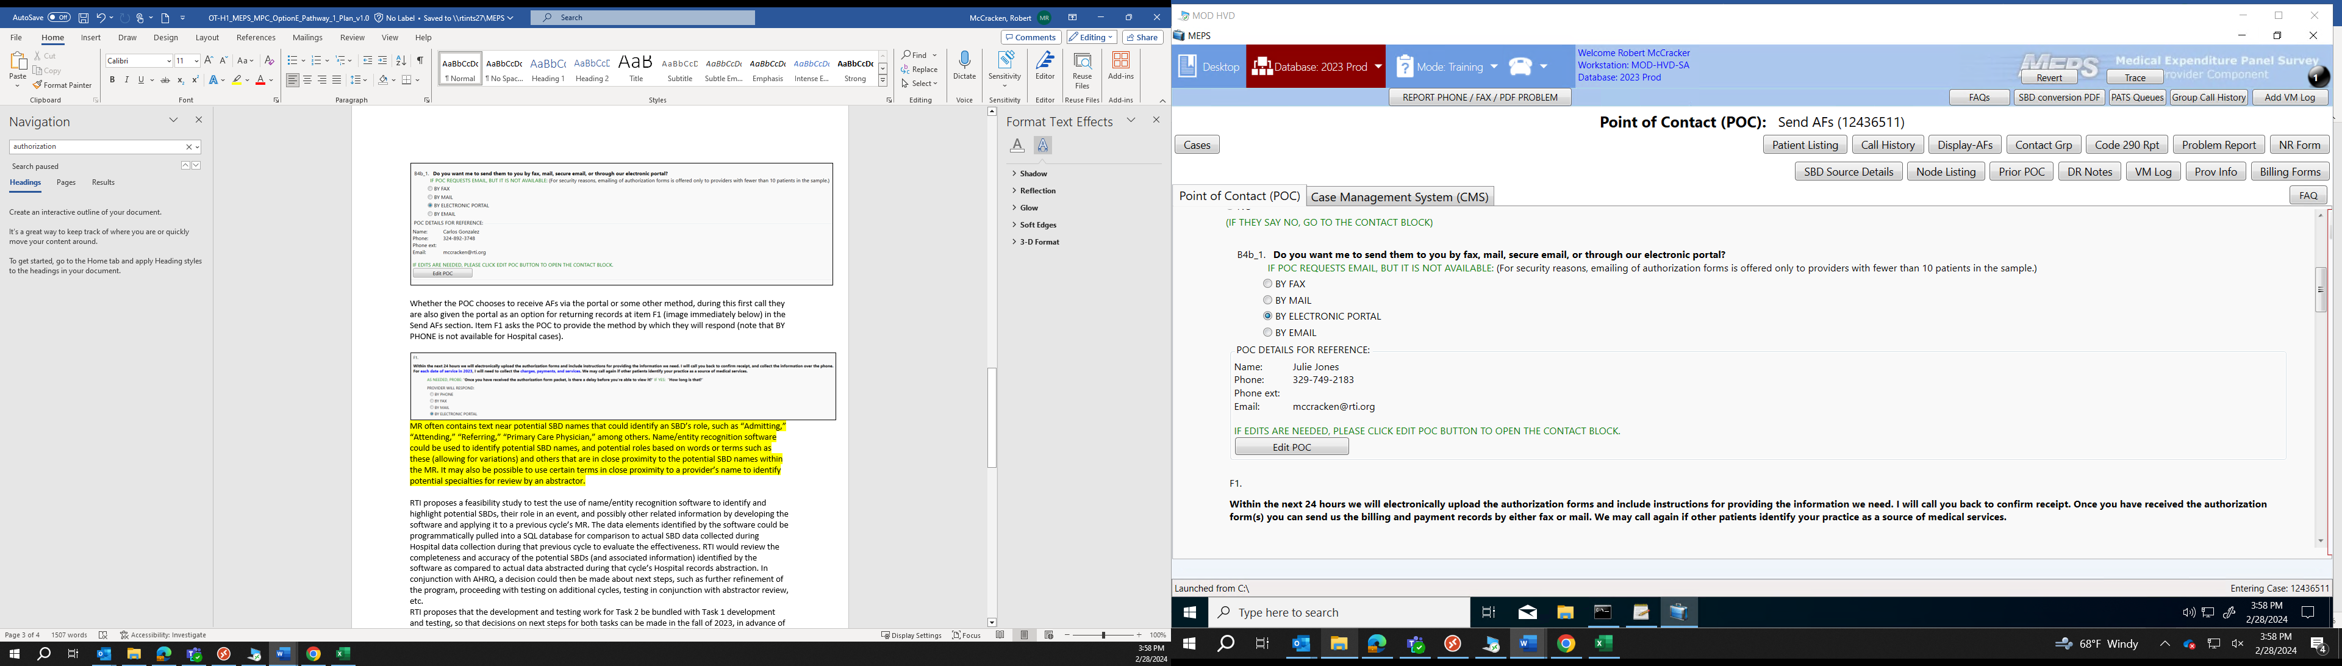

Whether the POC chooses to receive AFs via the portal or some other method, during this first call they are also given the portal as an option for returning records at item F1 (image immediately below) in the Send AFs section. Note that BY PHONE is also available for non-Hospital cases. If the POC chooses a non-portal method for receiving AFs, but chooses to return records via the portal, they receive an email with a link to the portal and brief instructions for using the portal to return records.

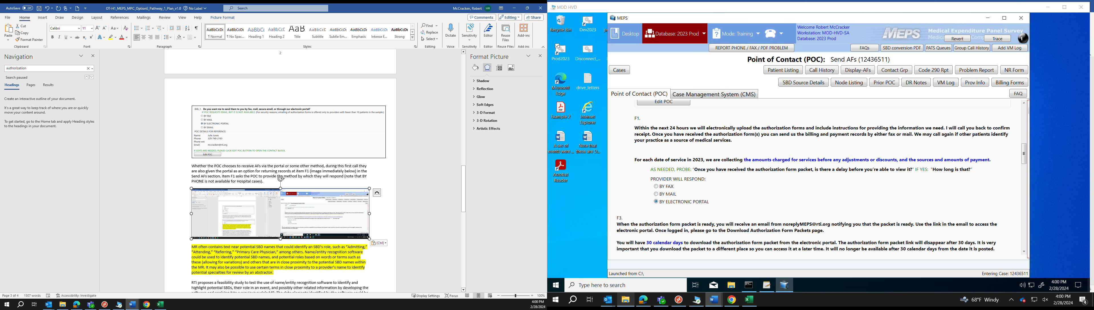

Finally, during the first call if the POC chooses to use the portal for receiving AFs and/or returning records, then item F3 (shown immediately below) is covered with the POC. This item provides more detail about the email the POC will receive. If the POC is receiving AFs via the portal, then more detail is covered about retrieving AFs from the portal. Note that the text displayed depends on whether the POC is using the portal to receive AFs, return records, or both.

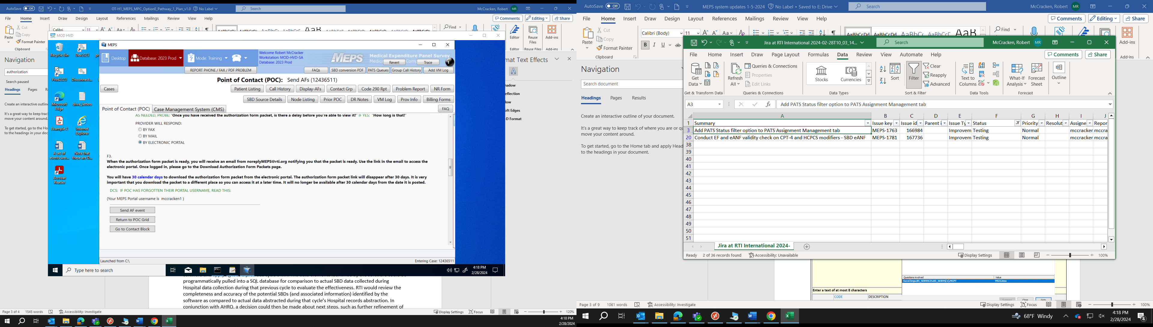

**Task 3: Provide data on current provider usage**

When looking at electronic portal usage, both AF packets sent and records received can be compared across cycles. *Table 1* compares contact groups with AFs sent by method for the 2021 – 2023 cycles. Data are provided from the start of data collection through March 17th for each cycle. The table includes counts of Hospital, OBD, and Pharmacy cases. The electronic portal accounts for 3.0% of contact groups with AFs sent for the 2023 cycle, which is an increase compared to 2021 and 2022. Note that email was not available as a method for sending AFs before the 2023 cycle. When email and the portal are combined (both being electronic delivery methods), 6.7% of packets have been sent electronically to date in the 2023 cycle.

**Table 1. Groups with AFs sent by method sent through March 17th, across cycles 2021 - 2023**

|  |  |  |  |
| --- | --- | --- | --- |
| **Groups with AFs Sent by…** | **2021** | **2022** | **2023** |
| Mail | 33 (4.3%) | 31 (3.9%) | 19 (3.5%) |
| Fax | 728 (93.8%) | 753 (95.0%) | 487 (89.9%) |
| Portal | 15 (1.9%) | 9 (1.1%) | 16 (3.0%) |
| Email | NA | NA | 20 (3.7%) |
| TOTAL | 776 | 793 | 542 |

The portal can also be used to receive records from POCs. *Table 2* shows records received by method received across the 2021 – 2023 cycles. Data are provided from the start of data collection through March 17th for each cycle. The table includes counts of Hospital, OBD, and Pharmacy records. The records received by portal in the 2023 cycle are similar to the percentage of all records received compared to the 2022 cycle. During the 2021 cycle, no records had been received by portal as of March 17th that cycle. Note that the Unknown category for records received is comprised mostly of records that require further review before full receipting – these can be received via any method.

**Table 2. Records received by method received through March 17th, across cycles 2021 - 2023**

|  |  |  |  |
| --- | --- | --- | --- |
| **Method Received** | **2021** | **2022** | **2023** |
| Mail | 2,534 (24.5%) | 1,671 (17.1%) | 1,836 (21.4%) |
| Fax | 7,207 (69.7%) | 7,334 (75.1%) | 6,140 (71.4%) |
| Portal | 0 (0.0%) | 343 (3.5%) | 299 (3.5%) |
| Unknown | 604 (5.8%) | 423 (4.3%) | 321 (3.7%) |
| TOTAL | 10345 | 9771 | 8596 |

While the 2023 cycle is still being conducted, the next two tables provide final portal use numbers for groups with AFs sent by method (*Table 3*) and pairs with records received by method (*Table 4*).

**Table 3. Final counts of groups with AFs sent by method sent, across cycles 2021 – 2022**

|  |  |  |
| --- | --- | --- |
| **Groups with AFs Sent by…** | **2021** | **2022** |
| Mail | 116 (6.1%) | 88 (5.2%) |
| Fax | 1,731 (90.3%) | 1,591 (93.3%) |
| Portal | 69 (3.6%) | 26 (1.5%) |
| Email | NA | NA |
| TOTAL | 1,916 | 1,705 |

**Table 4. Final counts of records received by method received, across cycles 2021 – 2022**

|  |  |  |
| --- | --- | --- |
| **Method Received** | **2021** | **2022** |
| Mail | 14,059 (32.0%) | 10,746 (27.3%) |
| Fax | 27,796 (63.2%) | 26,242 (66.7%) |
| Portal | 232 (0.5%) | 1,629 (4.1%) |
| Unknown | 1,881 (4.3%) | 708 (1.8%) |
| TOTAL | 43,968 | 39,325 |

**Task 4:** **Plan to discuss the current electronic portal with select POCs to gain insight into reluctance to use the portal and identify adjustments to materials and processes that might enhance provider usage**

To gather information on POC reluctance to use the portal, the team will collect information from 7 to 10 POCs. The sample of POCs will include some who have experience using the 2023 cycle version of the electronic portal, and a small number who have always chosen other methods for receiving AFs and returning data. Those who have never used the portal will be included to gather information about reasons they have avoided its use. First, POCs will be identified with the help of the data collection team – POCs who are cooperative and have used or attempted to use the portal, along with a few who have not used it. An attempt will also be made to identify POCs who have attempted to use the portal and encountered issues or problems.

The conversation with each POC will be guided by a pre-written set of questions (see attachment). The questions are designed to touch on each step of the process of using the portal – beginning with the DCS’s introduction of the portal as an option for receiving AFs and sending records. Questions also cover the functionality of each page within the portal site.

**Task 5: Pending outcomes of discussions with POC, we will identify adjustments that can be made to the portal and respondent materials in subsequent cycles of the MPC (Final version of Deliverable OT-H2)**

After completing discussions about the electronic portal with the selected POCs, a report will be compiled that will include a summary of the discussions, suggestions for improvements to the portal to enhance function and useability for POCs, and any reasonable alternate methods of record delivery that POCs may suggest.

The report summarizing the data collection process and detail about findings is attached as Appendix B.